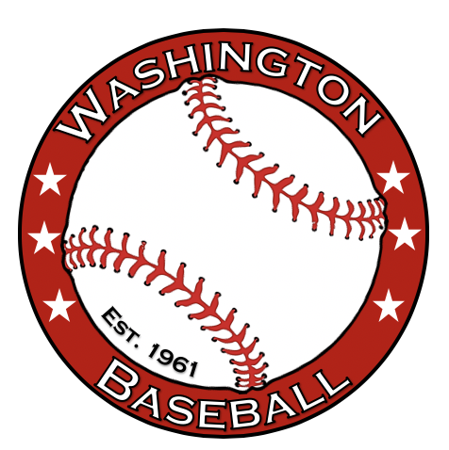

**Washington Baseball Coronavirus/Covid-19 Policy**

MHSAA posted updates as part of the Return-to-Play policy dated March 16th, 2021. Washington Baseball has made modifications to this document to be more baseball specific. Any items not covered in the Washington Baseball recommendations shall follow the MHSAA policy.

1. All Officials, Coaches and players shall be screened daily prior to attendance for signs and symptoms of Covid-19, including a temperature check. Anyone with a temperature above 100.3 degrees or any other positive signs/symptoms for Covid-19 shall stay home and notify the coaching staff.
2. Coaches must keep accurate records of athletes and staff who attend any practice/game in case contact tracing is required.
3. Umpires shall have masks on at all times.
4. All individuals shall avoid touching their eyes, nose or mouth.
5. Face masks are optional for athletes in active participation in baseball however are recommended when not involved in active participation and cannot maintain 6 feet of distance from others.
6. Only players/coaches/managers/officials are allowed in the dugouts/bench.
7. Spectators shall wear face masks at all times while sitting in bleachers or a fixed spectator seating area, or while in public areas and unable to maintain 6 feet of distance from one another.
8. There shall be no scrimmages allowed for baseball.
9. Seeds, gum and spitting are not permitted.
10. Each participant shall bring their own water bottle which must be marked with name and cannot be shared.
11. Coaches shall work to continue to reinforce safe and healthy habits.
12. No pregame or post-game handshakes, high-fives, or fist bumps. A raise of hat is recommended across to the field to opposing team.
13. Sanitizer will be available in all team bags.
14. Games that are cancelled because of Covid-19 are considered cancelled as a result of an act of God.

*Questions above this policy shall view the document on the waaabaseball.com called MHSAA Covid-19 Policy.*